BUSINESS INSIGHT REPORT
Northwind Interactive Sales Dashboard – Power BI Analysis

Name: Adhinarayanan V
Dep: B.com fintech with AI
Reg: 5272510201

2. Introduction
This report analyses the Northwind Traders sales dataset through an interactive Power BI dashboard. Northwind is a trading company that sells food and beverage products to customers in many countries, and its data records orders, products, categories, employees, customers and freight costs.
- Dataset: Northwind Traders order data: 809 orders, 51,317 units sold, 91 customers in 21 countries, 8 product categories and 9 employee records (including orders with no employee recorded).
- Purpose of the dashboard: to give a single, interactive view of orders, sales, freight and customers, and to compare performance by month, product category and employee.
- Purpose of this report: to interpret what the dashboard shows, identify the main business insights and recommend actions.

3. Dashboard Overview

Dashboard Screenshot
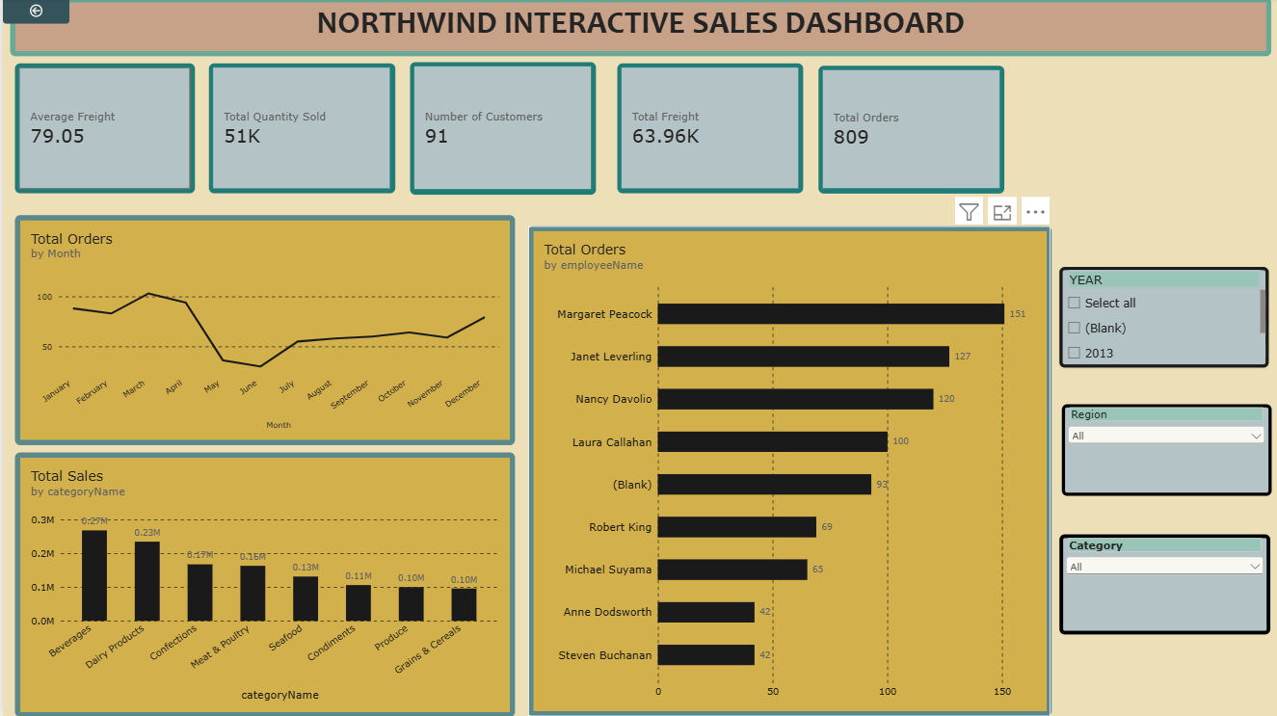
Figure 1: Northwind Interactive Sales Dashboard (no filters applied)
Purpose of the dashboard
The dashboard lets managers monitor order activity, sales and freight at a glance, and use filters to explore where performance is strong or weak.
Key components
- KPI cards: Average Freight, Total Quantity Sold, Number of Customers, Total Freight and Total Orders (the "Sales Overview" page also shows Total Sales)
- Orders by Month (line chart)
- Sales by Product Category (column chart)
- Orders by Employee (bar chart)
- Category Tooltip: hovering over a category shows Total Orders, Total Quantity Sold and Total Sales
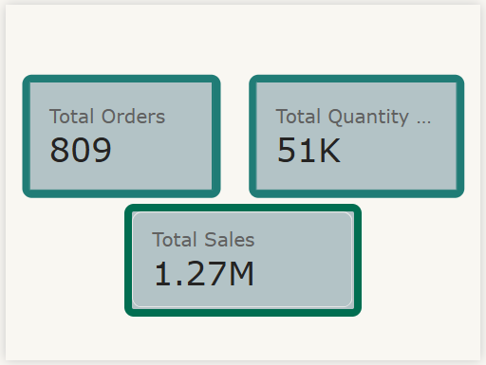
Figure 2: Category tooltip page
Interactive filters available
- Year: selecting a year limits every visual to that year.
- Region: a dropdown (currently "All") that filters the KPIs, charts and employees to the chosen region.
- Category: a dropdown (currently "All") that filters the dashboard to a single product category.
The report also includes a "Sales Overview" page and a "Product & Customer Analysis" page (customers by country and a product table), which are used in sections 7 and 9.

4. KPI Analysis
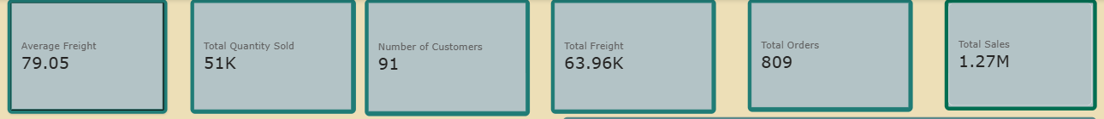
Figure 3: KPI cards
KPI | Value | Interpretation
Total Orders | 809 | Overall order activity over the period. Each customer placed about 9 orders on average (809 ÷ 91), which shows repeat buying.
Total Quantity Sold | 51K (51,317 units) | Overall volume of products sold. With about 63 units per order, customers tend to buy in bulk, as expected for a trading company.
Total Freight | 63.96K | Total shipping cost. It equals about 5% of total sales (63.96K ÷ 1.27M), so freight is a noticeable but manageable cost.
Average Freight | 79.05 | Average freight per order (63.96K ÷ 809). Compared with an average order value of about 1,565, freight is about 5% of each order.
No. of Customers | 91 | Customer coverage across 21 countries. Sales per customer are about 13,900, so the business depends on a fairly small base of repeat customers.
Total Sales | 1.27M (1,265,793.04) | Overall revenue. Average sales are about 1,565 per order and about 24.7 per unit sold.

5. Product Category Performance Analysis
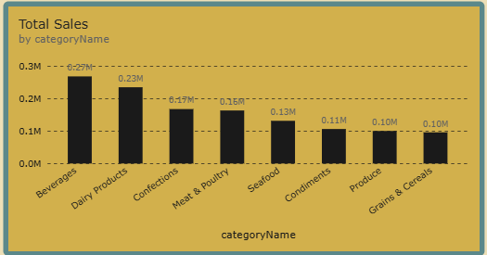
Figure 4: Total Sales by Product Category
Item | Observation
Highest-selling category | Beverages, at about 0.27M (about 21% of total sales).
Lowest-selling category | Produce and Grains & Cereals, both at about 0.10M (tied at the rounded value).
Relative differences | Beverages sells about 2.7 times as much as the lowest categories. The order is Beverages 0.27M, Dairy Products 0.23M, Confections 0.17M, Meat & Poultry 0.16M, Seafood 0.13M, Condiments 0.11M, Produce 0.10M, Grains & Cereals 0.10M.
Important observations | Beverages and Dairy Products together make about 0.50M, roughly 39% of sales. The top three categories (adding Confections) make about 53%. The five lower categories each stay between 0.10M and 0.16M.

Key Insight
Sales depend heavily on Beverages and Dairy Products. These categories deserve priority in stock, supplier relations and promotion, while Produce and Grains & Cereals need a plan to grow or be kept lean.

6. Monthly Order Trend Analysis
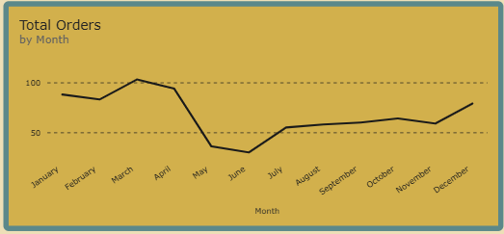
Figure 5: Total Orders by Month
Item | Observation
Highest-order month | March, at about 100 orders (the chart is slightly above the 100 line).
Lowest-order month | June, at about 30 orders, followed by May at about 37.
Overall pattern | Orders are high from January to April (about 83 to 103 per month), drop sharply in May and June, recover gradually from July to October (about 55 to 64) and rise again in December (about 79).
Major fluctuations | The drop from April (about 94) to May (about 37) is the biggest change, a fall of about 60%. January to April alone make up roughly 45% of all orders.

Note: the monthly values are read from the line chart, which has no data labels, so they are approximate. The May and June dip may partly reflect months that are missing from some years of the data; this can be checked with the Year slicer.
Key Insight
Orders are strongly seasonal, with a busy first four months and a very quiet May and June. Staffing, stock and promotions should be planned around this pattern.

7. Regional / Filter-Based Analysis
The dashboard has a Region slicer, so selecting a region recalculates the KPIs, category chart, monthly chart and employee chart for that region. The "Product & Customer Analysis" page shows where the 91 customers are located, which gives a regional view of the market.
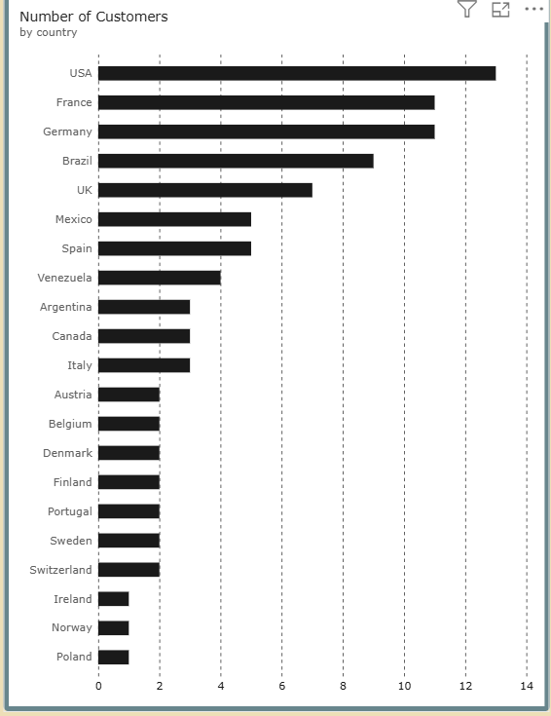
Figure 6: Number of Customers by Country
Region / Country | Major Observation | Business Insight
USA | Most customers: 13 (about 14% of 91). | The largest single market and the most important country to protect.
France and Germany | 11 customers each (about 12% each). | Strong European markets that together hold about 24% of customers.
Brazil | 9 customers (about 10%). | The main market in South America and the fourth largest overall.
UK | 7 customers (about 8%). | Mid-sized market with room to grow.
Other 16 countries | Between 1 and 5 customers each (40 customers in total, about 44%). | Many small markets: 10 countries have only 1 or 2 customers, so this is a growth opportunity but also a concentration risk.

Effect of the filters
- KPI changes: selecting a region reduces Total Orders, Quantity, Freight and Sales to that region's share.
- Category changes: the category chart shows which categories sell best in that region.
- Monthly order changes: the line chart shows that region's own seasonal pattern.
- Employee performance changes: the employee bars show which employees handle that region's orders.
Screenshots of the dashboard with a single region selected were not available when this report was written, so the regional table uses the customer-by-country chart and the filter effects are described rather than quoted.
Key Insight
The top five countries (USA, France, Germany, Brazil, UK) hold about 56% of customers. The business is concentrated in a few markets, so protecting these customers while growing the 10 countries with only 1 or 2 customers is a key regional priority.

8. Employee Performance Analysis
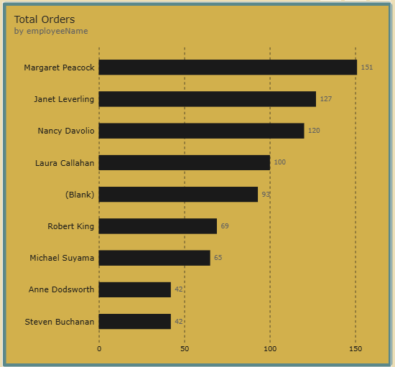
Figure 7: Total Orders by Employee
Item | Observation
Highest-performing employee | Margaret Peacock, with 151 orders (about 19% of all orders).
Lowest-performing employee | Anne Dodsworth and Steven Buchanan, with 42 orders each.
Difference between employees | Margaret Peacock handles about 3.6 times as many orders as the lowest employees (151 vs 42), a gap of 109 orders. The top three (Peacock 151, Leverling 127, Davolio 120) handle 398 orders, about 49% of the total.
Changes after applying filters | Choosing a Year, Region or Category recalculates the bars, so the ranking can change by market or time period.

Also, 93 orders (about 11.5% of the total) appear under (Blank), meaning no employee is recorded for them. The employee bars add up to 809 orders, which confirms this.
Key Insight
Order handling is uneven: half of all orders go through three employees. Workload could be rebalanced, and the 93 unassigned orders show a data-quality or process gap that makes performance tracking less reliable.

9. Business Insights
Observation = what the data shows. Insight = what the observation means for the business.
Insight 1: Sales are concentrated in a few categories
Observation: Beverages (0.27M) and Dairy Products (0.23M) make about 39% of the 1.27M sales, and the top three categories make about 53%. Insight: the business relies on a small group of categories, so stock-outs or supplier problems in Beverages or Dairy would hit revenue hard, and these categories should be protected first.
Insight 2: Orders are highly seasonal
Observation: orders peak at about 100 in March and fall to about 30 in June, and January to April account for about 45% of all orders. Insight: demand is not even through the year, so inventory, staffing and marketing should be concentrated in the busy months, with promotions to lift the quiet months.
Insight 3: Workload and customers are concentrated
Observation: three employees handle about 49% of orders, and five countries hold about 56% of customers. Insight: the business depends on a few people and a few markets, which raises the risk if a key employee leaves or a key market slows down.
Insight 4: Freight is a meaningful cost
Observation: freight is 63.96K, about 5% of sales, with an average of 79.05 per order. Insight: because freight is a steady cost on every order, even a small reduction in the average freight per order would improve profit across 809 orders.
Supporting detail: the product table (see Appendix) shows large differences in value per unit. For example Mishi Kobe Niku earned 7,226.50 from only 95 units, while Geitost earned 1,648.13 from 755 units, so a few high-priced products carry a lot of revenue.

10. Business Recommendations
- Product category planning: Prioritise stock, supplier agreements and promotions for Beverages and Dairy Products, and set growth targets or a range review for Produce and Grains & Cereals.
- Inventory planning: Hold more stock for the busy January to April period and for December, and keep inventory lean for May and June to avoid tied-up cash.
- Monthly order planning: Run targeted promotions, discounts or bundles in May and June to lift orders in the quietest months, and plan staffing around the seasonal pattern.
- Regional strategy: Protect relationships in the USA, France, Germany, Brazil and the UK, and develop the countries with only 1 or 2 customers through targeted outreach.
- Employee performance: Rebalance order handling across employees, share the practices of Margaret Peacock and Janet Leverling with lower-volume staff, and make sure every order is assigned to an employee.
- Freight management: Negotiate better carrier rates, consolidate shipments and consider minimum order values or free-shipping thresholds to reduce the 79.05 average freight per order.
- Customer targeting: With about 9 orders per customer, introduce loyalty offers for repeat customers and use the Region and Category filters to find under-served customers to target.

11. Conclusion
- Overall dashboard findings: the dashboard shows 809 orders, 51,317 units, 1.27M in sales and 63.96K in freight from 91 customers in 21 countries.
- Most important business insight: sales, orders and customers are concentrated: two categories bring about 39% of sales, four months bring about 45% of orders, and five countries hold about 56% of customers.
- Key recommendation: plan inventory and promotions around the strongest categories and the seasonal pattern, while reducing freight cost and widening the customer base.
- How Power BI helped: interactive slicers, cross-filtering charts and DAX measures (Total Orders, Total Sales, Total Freight, Average Freight, Number of Customers) made it quick to explore the data by year, region and category and to turn raw order records into clear business insights.

Appendix: Product Table
The "Product & Customer Analysis" page lists total sales and quantity sold by product, and its totals (1,265,793.04 in sales and 51,317 units) match the KPI cards on the dashboard.
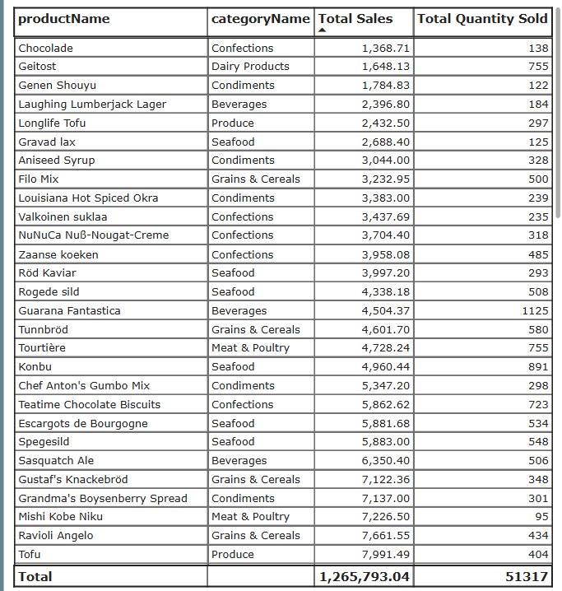
Figure 8: Product sales and quantity table

